**Investigating Intermolecular Attractions**

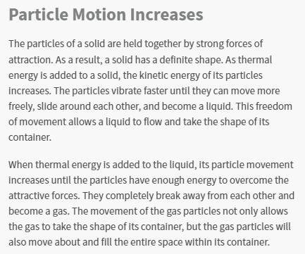

**Learning Outcomes**

Students will use particle models to explain what happens during a change of state, and recognize that changes of state occur as a result of variations in temperature or pressure.

Students will be able to model and explain how a change in thermal energy can influence a change of state.

**Claim**

The strength of intermolecular attractions between molecules influences the boiling point of the substance.

**Background**

We can observe the strength of intermolecular attractions by looking at cohesion within the substance. In liquids, cohesion is observable as surface tension or the liquid's "beading." If the molecules pull tightly together, then there is strong cohesion and strong intermolecular attractions.

**Goal**

We will observe droplets of several different liquids and compare these to the boiling points. We will determine if our claim is supported or not.

| **Substance** | **Drop Shape** | **Drawing of Drop from the top** | **Drawing of Drop from the side** | **How strong do you think the intermolecular attractions are?**  **Strong, weak, middle?** |
| --- | --- | --- | --- | --- |
| Water |  |  |  |  |
| Veggie Oil |  |  |  |  |
| Rubbing Alcohol |  |  |  |  |
| Vinegar |  |  |  |  |
| Dish Soap |  |  |  |  |

**Boiling Points**

| **Substance** | **Strength of Attractions** | **Melting Point** | **Boiling Point** | **Substance** | **Strength of Attractions** | **Melting Point** | **Boiling Point** |
| --- | --- | --- | --- | --- | --- | --- | --- |
| **Water** |  | 0℃ | 100℃ | **Vinegar** |  | 16℃ | 118℃ |
| **Veggie Oil** |  | -10℃ | 200℃ | **Dish Soap** |  | -10℃ | 94℃ |
| **Rubbing Alcohol** |  | -89℃ | 82.5℃ |  | | | |

**Did we support our claim?**

| The strength of intermolecular attractions between molecules influences the boiling point of the substance. |
| --- |
| **Evidence:** |
| **Reasoning (explanation):** |